Saturday, December 22, 2018

CHAPTER 10

P.P.10.1
Hence, the circuit in the frequency domain is as shown below.

-j2.5

+

V_{x}

4

j4

100 A

+

3V_{x}

2

V₁

V₂

At node 1,
(1)

At node 2, where
(2)

Put (1) and (2) in matrix form.
where

In the time domain,
11.325 cos(2t + 60.01) V
33.02 cos(2t + 57.12) V

P.P.10.2 The only non-reference node is a supernode.
(1)

The supernode gives the constraint of
(2)

Substituting (2) into (1) gives

Therefore, 96.869.66 V, 16.88165.72 V

P.P.10.3 Consider the circuit below.

6

j4

8

-j2

I₁

I₂
+

5030 V

I₃

100 A

For mesh 1,
(1)

For mesh 2,

For mesh 3,

Thus, the equation for mesh 2 becomes
(2)

From (1), (3)

Substituting (3) into (2),

Hence,
5.96965.45 A

P.P.10.4 Meshes 2 and 3 form a supermesh as shown in the circuit below.

10

600 V
+

I₁

-j4

5

j8

-j6

I₃

I₂

For mesh 1,
(1)

For the supermesh, (2)

Also, (3)

Eliminating from (1) and (2)
(4)
(5)

From (4) and (5),

Thus, 6.0895.94 A

P.P.10.5 Let , where and are due to the voltage source and current source respectively. For consider the circuit in Fig. (a).

8

-j2

6

I₁

5030 V
+

j4

I₂

I_{o}'

(a)

For mesh 1,
(1)

For mesh 2, (2)

Substituting (1) into (2),

For consider the circuit in Fig. (b).

6

j4

8

-j2

100 A

I_{o}"

(b)

Let ,

Therefore,
5.9765.45 A

P.P.10.6 Let , where is due to the voltage source and is due to the current source. For , we remove the current source.

The circuit in the frequency domain is shown in Fig. (a).

+

V_{o}'

+

750 V

8

-j

j5

(a)

Note that

By voltage division,
Thus,

For , we remove the voltage source.

The corresponding circuit in the frequency domain is shown in Fig (b).

+

V_{o}"

-j0.5

j10

8

60

I

(b)

Let ,

By current division,
Thus,

Therefore,
11.577 sin(5t – 81.12) + 3.154 cos(10t – 86.24) V

P.P.10.7 If we transform the current source to a voltage source, we obtain the circuit shown in Fig. (a).

(a)

V_{S}
+

4

j

-j3

2

-j2

1

I_{o}

j5

We transform the voltage source to a current source as shown in Fig. (b).
Let . Then, .

(b)

-j2

6

I_{o}

-j2

1

j5

I_{S}
Note that .

By current division,
9.86399.46 A

P.P.10.8 When the voltage source is set equal to zero,
12.4 – j3.2

By voltage division,
63.24–51.57 V

P.P.10.9 To find , consider the circuit in Fig. (a).

V₁

V₂

4 – j2

8 + j4

a

b

50

0.2V_{o}

(a)

+

V_{o}

4 – j2

8 + j4

a

b

0.2V_{o}

(b)
+

10

+

V_{o}

I_{s}

V_{S}

At node 1,
(1)

At node 2, , where .

Hence, the equation for node 2 becomes
(2)

Substituting (2) into (1),
7.3572.9 V

To find , we remove the independent source and insert a 1-V voltage source between terminals a-b, as shown in Fig. (b).

At node a,

But, and –
So,
and
4.473–7.64

P.P.10.10 To find , consider the circuit in Fig. (a).

j2

4

-j3

8

1

Z_{N}

a

b

(a)

j2

4

-j3

8

1

a

b

(b)

I_{N}

I₂
+

200

I₁

I₃

-j4

3.176 + j0.706

To find , short-circuit terminals a-b as shown in Fig. (b). Notice that meshes 1 and 2 form a supermesh.

For the supermesh, (1)

Also, (2)

For mesh 3, (3)

Solving for , we obtain
8.396–32.68 A

Using the Norton equivalent, we can find as in Fig. (c).

I_{N}

10 – j5

Z_{N}

(c)

I_{o}

By current division,
1.9714–2.10 A

P.P.10.11

Consider the circuit in the frequency domain as shown below.
+

+

10 k

20 k

-j20 k

-j10 k

I_{o}

V_{o}

V₂

V₁

120 V

As a voltage follower,

At node 1,
(1)

At node 2,
(2)

Substituting (2) into (1) gives
or

Hence,
4 sin 5,000t V

Now,
But from (2)

Hence,
400 sin 5,000t A

P.P.10.12 Let

The loop gain is
where

G = 1.0147–5.6

P.P.10.13 The schematic is shown below.

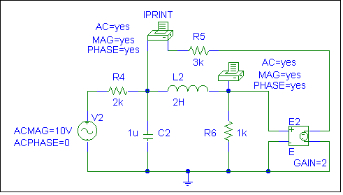
ACMAG = 20V
ACPHASE = 0

Since . Setup/Analysis/AC Sweep as Linear for 1 point starting and ending at a frequency of 447.465 Hz. When the schematic is saved and run, the output file includes

Frequency | IM(V_PRINT1) | IP(V_PRINT1)
4.775E+02 | 1.088E-03 | -5.512E+01

Frequency | VM($N_0005) | VP($N_0005)
4.775E+02 | 5.364E-01 | -1.546E+02

From the output file, we obtain
0.2682-154.6 V and 0.544-55.12 mA

Therefore,
536.4 cos(3,000t – 154.6) mV
1.088 cos(3,000t – 55.12) mA

P.P.10.14 The schematic is shown below.
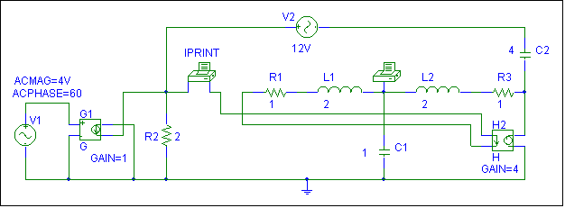

ACMAG=16v
ACPHASE=60

48 V

Since PSpice does not allow the use of complex impedances, we need to convert the complex impedances into values of capacitance and inductance. We select ω = 1 rad/s which generates f = 0.15915 Hz. We use this to obtain the values of capacitances, where, and inductances, where . Since AC current sources in PSpice does not allow the use of phase angles but AC voltages do, we can replace the current source with a voltage controlled current source. Thus we not have created an AC current source with a magnitude and a phase.

To obtain the desired output use Setup/Analysis/AC Sweep as Linear for 1 point starting and ending at a frequency of 0.15915 Hz. When the schematic is saved and run, the output file includes

Frequency | IM(V_PRINT1) | IP(V_PRINT1)
1.592E-01 | 10.336E+00 | 1.580E+02

Frequency | VM($N_0004) | VP($N_0004)
1.592E-01 | 39.368E+00 | 4.478E+01

From the output file, we obtain

39.3744.78 V and 10.336158 A

P.P.10.15 10 F

P.P.10.16 If and
63.66 kHz

